Game Graphics

A variety of computer graphic techniques have been used to display video game content throughout the history of video games. The predominance of individual techniques have evolved over time, primarily due to hardware advances and restrictions such as the processing power of central or graphics processing units.

1- Text based graphics

A text game or text-based game is a video game that uses text characters instead of bitmap or vector graphics. Text-based games were a popular form of interactive fiction in the 1980s.

2-Vector graphics

Vector graphics is the use of polygons to represent images in computer graphics. Vector graphics are based on vectors, which lead through locations called control points or nodes. Each of these points has a definite position on the x and y axes of the work plane and determines the direction of the path; further, each path may be assigned a stroke color, shape, thickness, and fill.

3-Full motion video

A full motion video (FMV) is a video game narration technique that relies upon pre-recorded video files (rather than sprites, vectors, or 3D models) to display action in the game. While many games feature FMVs as a way to present information during cutscenes, games that are primarily presented through FMVs are referred to as full-motion video games or interactive movies.

4-2D graphics

2D computer graphics is the computer-based generation of digital images—mostly from two-dimensional models (such as 2D geometric models, text, and digital images) and by techniques specific to them. The word may stand for the branch of computer science that comprises such techniques, or for the models themselves.

5-2.5D, 3/4 perspective, and pseudo-3D

2.5D ("two-and-a-half-dimensional"), ¾ perspective, and pseudo-3D are terms, mainly in the video game industry, used to describe either 2D graphical projections and similar techniques used to cause a series of images (or scenes) to simulate the appearance of being three-dimensional (3D) when in fact they are not, or gameplay in an otherwise three-dimensional video game that is restricted to a two-dimensional plane or has a virtual camera with a fixed angle. By contrast, games using 3D computer graphics without such restrictions are said to use true 3D.

6-3D

3D computer graphics (in contrast to 2D computer graphics) are graphics that use a three-dimensional representation of geometric data (often Cartesian) that is stored in the computer for the purposes of performing calculations and rendering 2D images. Such images may be stored for viewing later or displayed in real-time.

3D computer graphics rely on many of the same algorithms as 2D computer vector graphics in the wire-frame model and 2D computer raster graphics in the final rendered display. In computer graphics software, the distinction between 2D and 3D is occasionally blurred; 2D applications may use 3D techniques to achieve effects such as lighting, and 3D may use 2D rendering techniques.

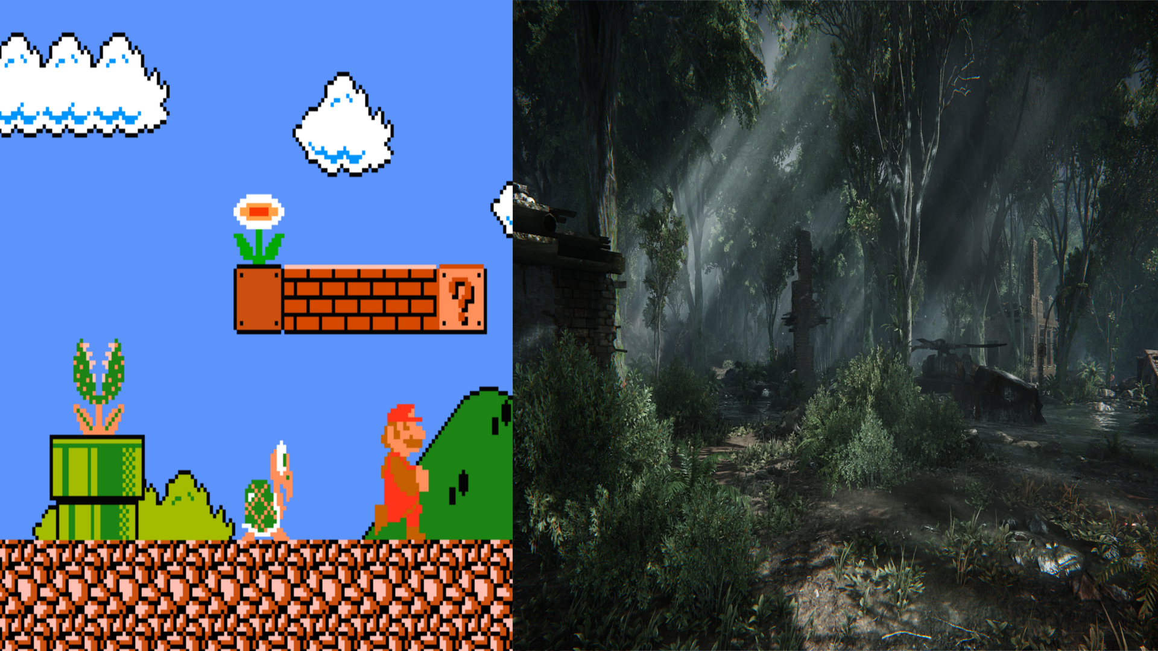

*Sources*

*Wikipedia*

*Google*